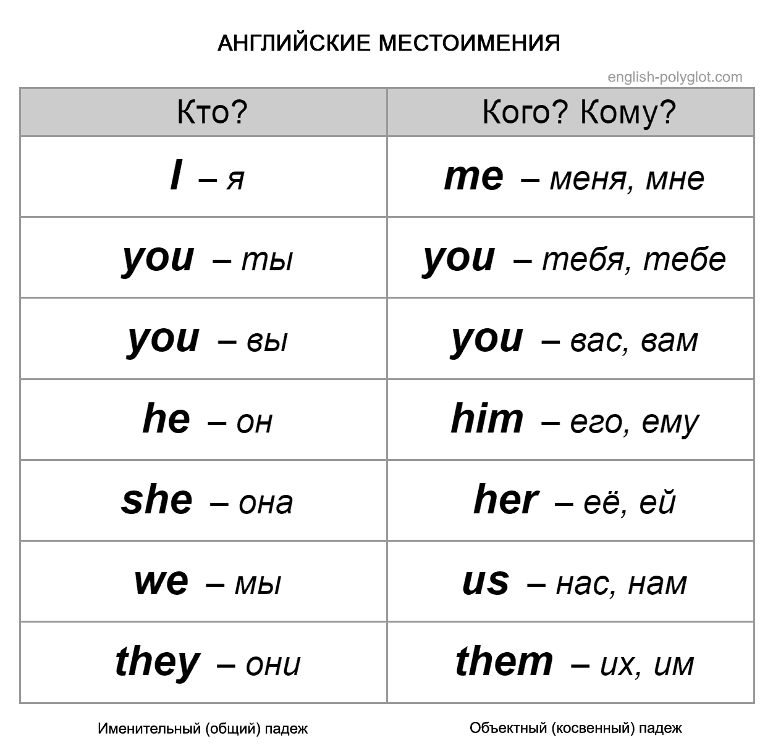
Упражнение 1. Change the words in the brackets to the appropriate pronoun (she, he, it, theу, we). Измени слова в скобках, используя личные местоимения в именительном падеже.
- (Kate) is not a typist.
- (These women) are not doctors.
- Is (that pear) red?
- (Those stories) are very interesting.
- (These pencils) are black.
- (This table) is brown.
- (My friends and I) are at school.
- (Greg) is at home now.
- (A man and two women) are in the car.
- (Mr. and Mrs. Baker) are in London.

Упражнение 2.Fill in the gap with the correct object pronoun. Заполните пропуски, используя личные местоимения в объектном падеже.
- Who is that lady? — Why are you looking at __________?
- Do you know that young handsome man?-Yes, I study with __________.
- Please, listen to _______. I want to express my point of view.
- These puppies are so nice! Do you want to look at ______.
- We like this house. We're going to buy _________.
- He can't see _______ because we are sitting in the last row.
- Where are the keys to our flat? I can't find _______.
- Where is Ann? I want to talk to _________.
- This snake is poisonous. I'm very afraid of _______.
- Don't wait for _______ for dinner. I'll return very late at night.
- He left Polotsk long ago. I haven't seen _______ since.
- You can fully rely on _______. We won't let you down.

Отправить на электронную почту фото или документ формата Word с выполненными упражнениями до 15:00 22.05.2020. Не забываем указывать свою фамилию.
Выполненные упражнения нужно присылать точно в указанный срок, если нет дз, будет стоять Н. Если по каким-то обстоятельствам не получается вовремя отправлять задания, то предупредите об этом.
Электронная почта: afanasievaalina97538@mail.ru

