Дата: 25.05.2020
Тема: Семейный отношения
Перед вами список слов по теме «Семья и семейные отношения». Просмотрите слова, а затем выучите их.
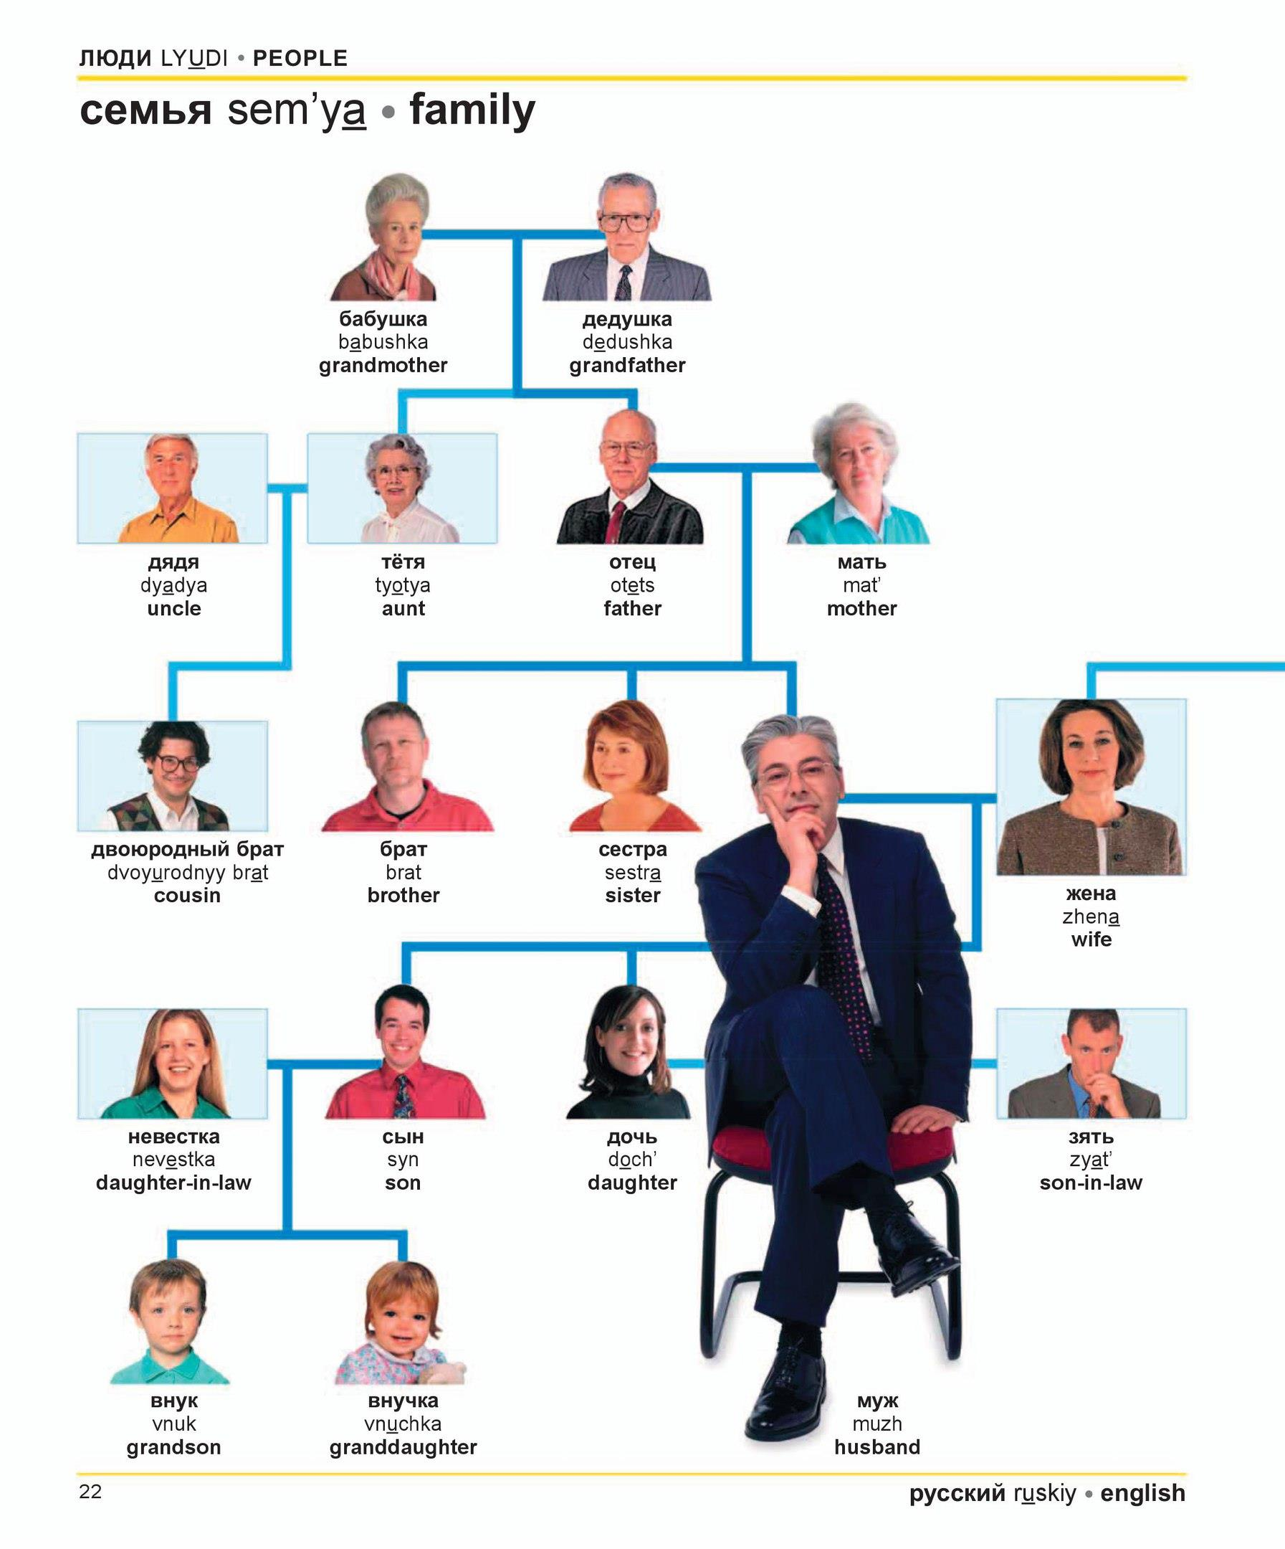

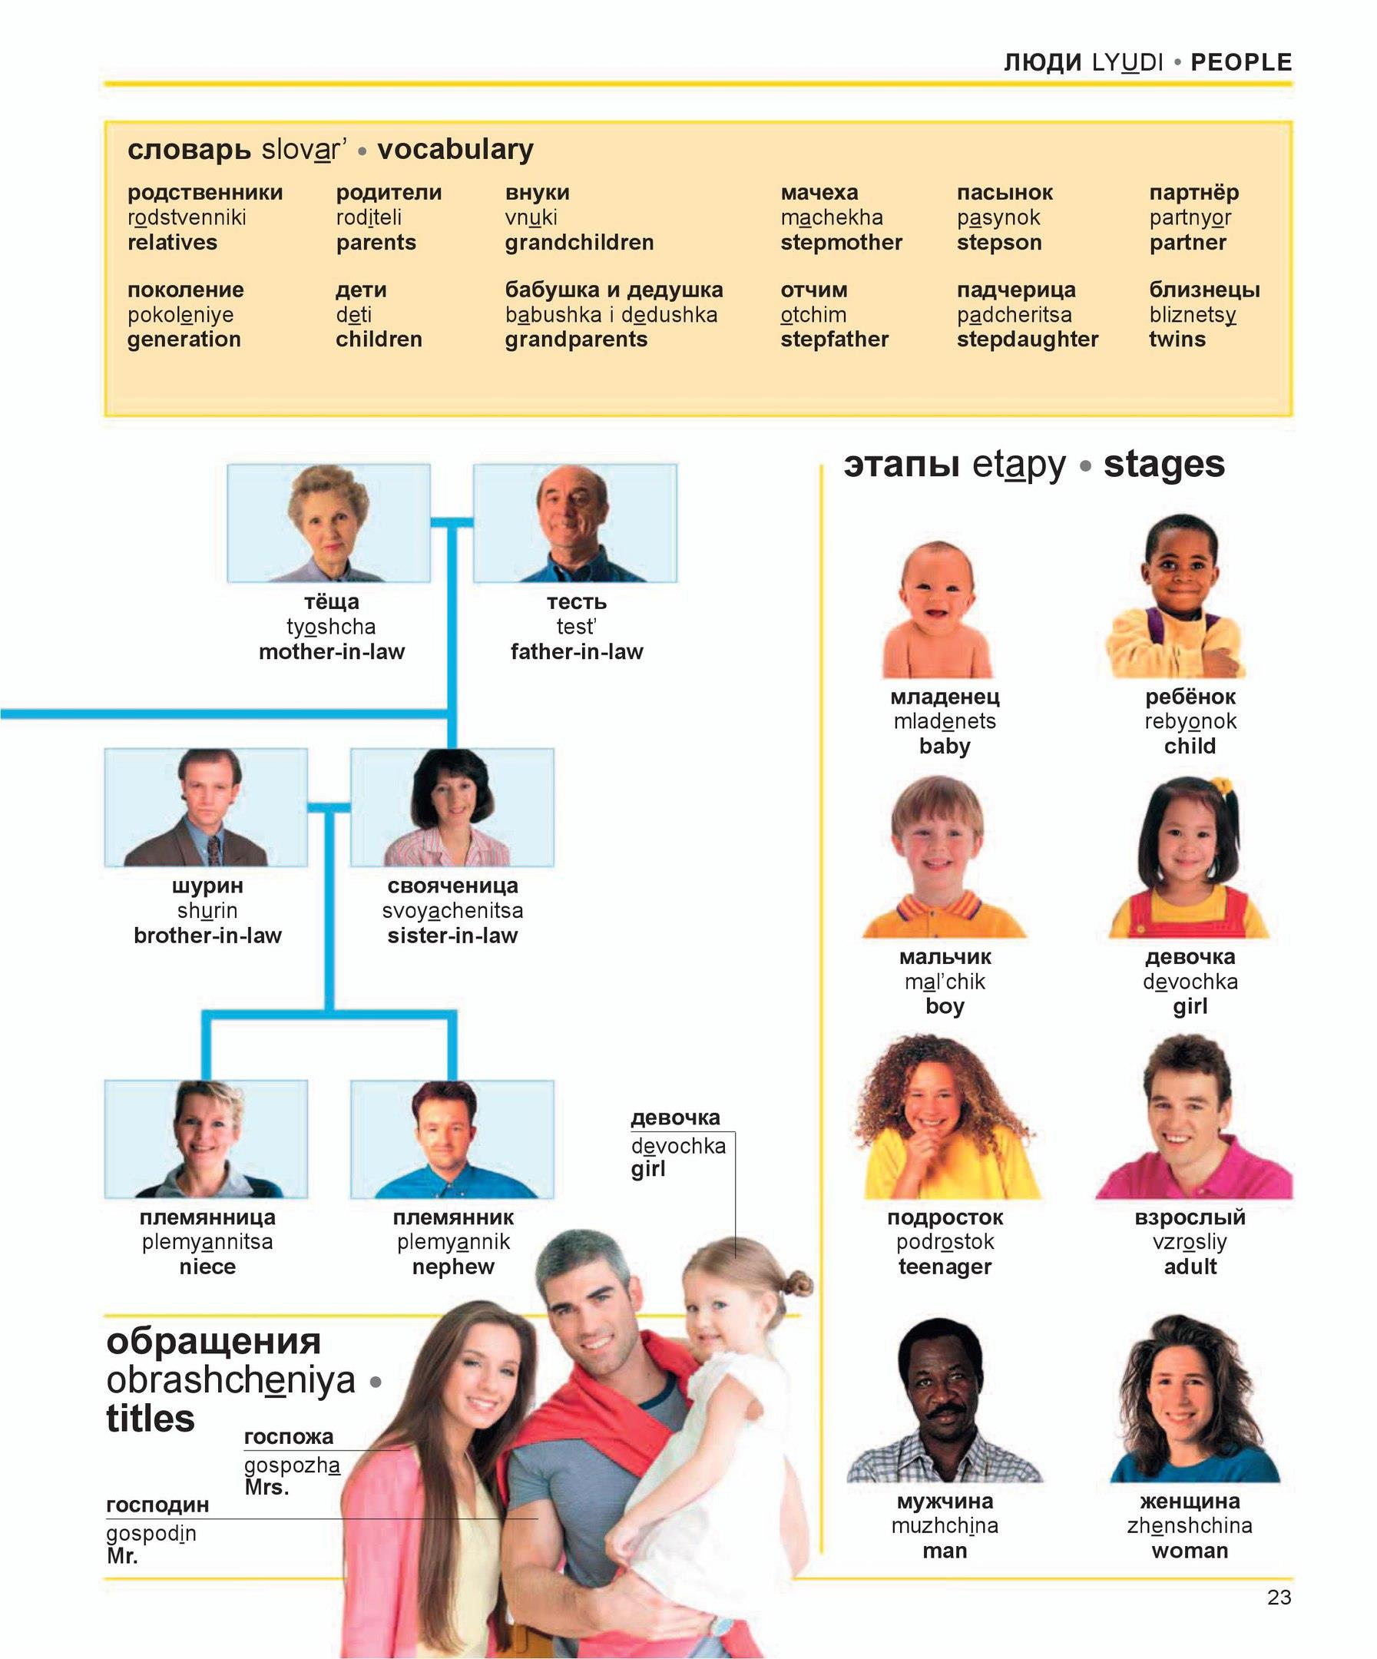
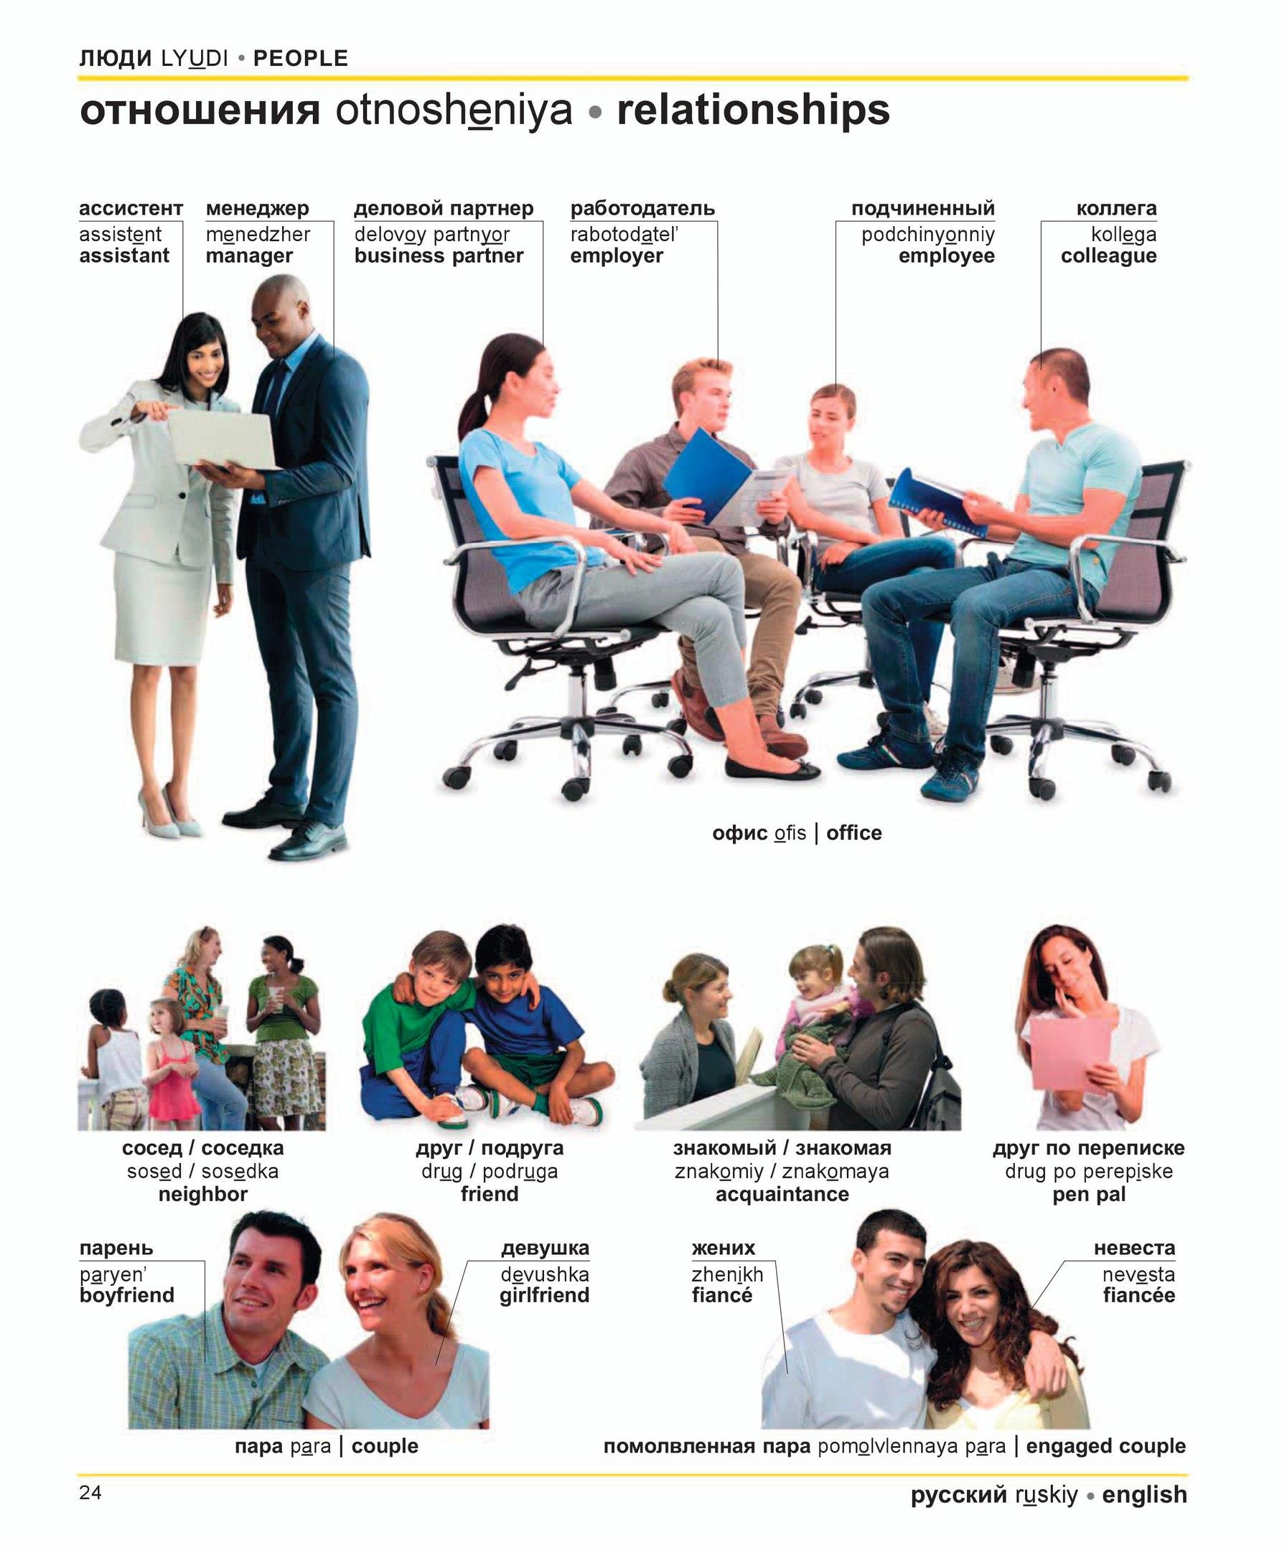
Task 1. Answer the questions:
- Do you have a pen pal? –
- Is it possible to have many friends? –
- What is generation gap? –
- Would you like to be employer or employee? –
- Do you know information about you family tree? –
You don’t have homework this time. Have a nice day!

